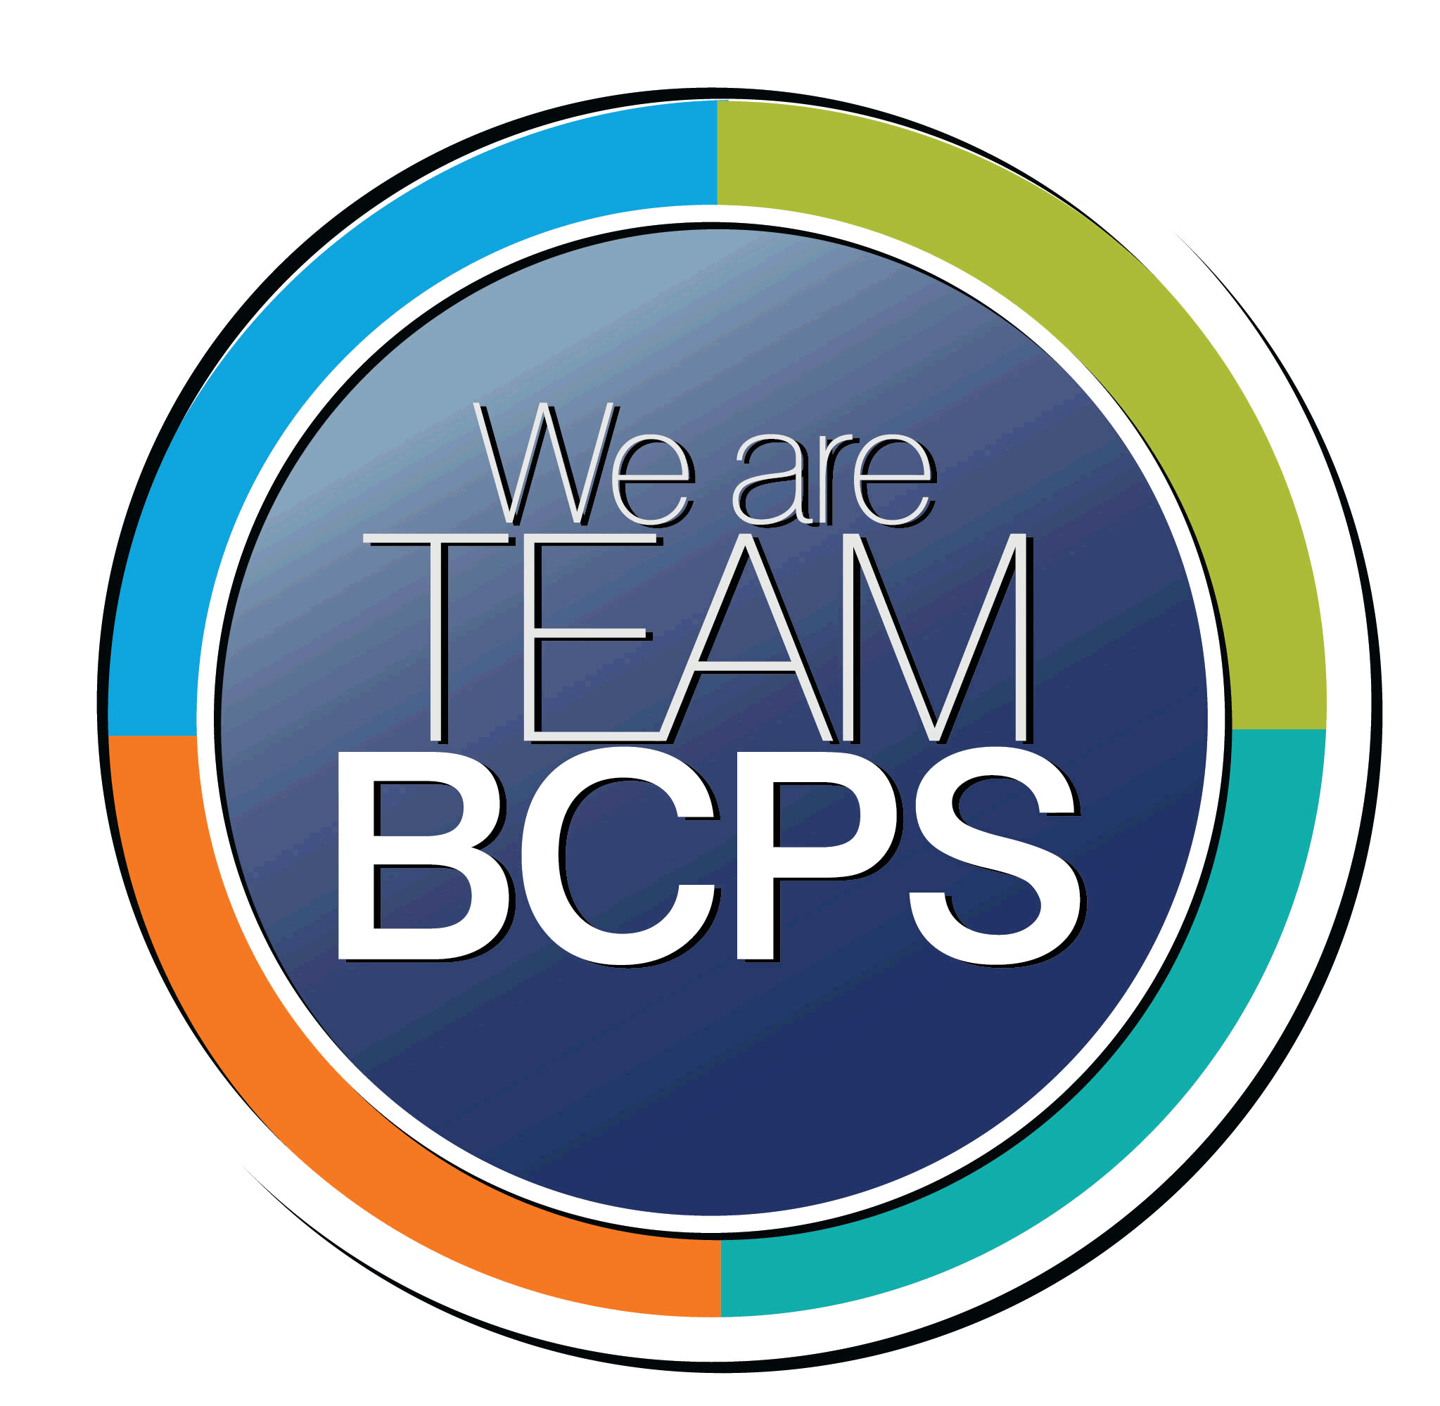 **Schoolwide Positive Behavior Plan** 

**Baltimore County Public Schools**

**Date Completed: 9/5/2023 School Year 2023-2024**

**School: Pikesville High School**

|  |
| --- |
| **Section 1: Initial Steps** |
|  |
| **School Climate Team** |
| *Identify members of a School Climate Team (consider a representative selection of members). The team meets initially to examine equity concerns and data and to develop the Schoolwide Positive Behavior Plan. The team should then meet monthly (minimum quarterly) to assess the effectiveness of the SWPBP on an ongoing basis.* |
| Eric Eiswert, Principal  Kathy Albert, Assistant Principal  Todd Hawkins, Assistant Principal  Dr. Otis Lee, Assistant Principal  Dominic Peters, Behavioral Interventionist  Nicole Lee-Khalif, School Social Worker  Jeremy Goldman, School Counseling Chairmen  Christal Higgins, AVID Coordinator  Core Content Department Chairs |
| **Equity Lens** |
| *Through an equity lens, identify what the data indicate about the social-emotional needs of students and the support provided by staff members relative to disproportionality between student groups, especially for African Americans or students receiving special education. Also consider the school’s population with regard to ELL, Latinx, and/or other student groups. (Information may be from School Data Story)* |
| As of the August 3rd enrollment, PHS has 934 students. This will most likely increase to over 910 by the beginning of the 2023/2024 school year. Our student demographics are as follows:   * 50% African American, 31% White, 10% Hispanic, 4% two or more races. * 31% of our students qualify for Free and Reduced Meals (FARMS) * 9% of students have an Individual Education Plan (IEP)   Pikesville High School prides itself as a diverse learning environment. Every initiative, policy, and practice at PHS is viewed through an equity lens. When examining data, we are deliberate in analyzing the story it is telling us about equitable practices and who is benefiting and who is suffering through those practices. This drive towards providing an equitable learning environment has been at the focal point of new all new school wide initiatives and practices. After reviewing school-level data for disparities, patterns, and themes among student groups (e.g., race, gender, disability, etc.) we analyze the data to determine what practices are advantaging some students and disadvantaging marginalized students. We then worked collaboratively to reduce disparities in both academic achievement and social and emotional well-being. |
| **Data Analysis** |
| *Summarize what the data tell about the school climate. (Information from School Data Story)* |
| The PHS data story informs us that we have many challenges ahead as a school community. At times, the data paints a picture of two different schools regarding scholastic achievement and a sense of belonging.  • Black/African American students are suspended at rates higher than their non-Black/African American peers. The suspension rate gap for Black/African American students at Pikesville High is greater than the same gap for all BCPS high schools. This gap has widened over time, indicating a negative trend. • Students eligible for FARMS are suspended at rates higher than their non-FARMS peers. The suspension rate gap for students eligible for FARMS at Pikesville High is greater than the same gap for all BCPS high schools. This gap has widened over time, indicating a negative trend. • Students eligible for Special Education are suspended at rates higher than their nonspecial Education peers. The suspension rate gap for students eligible for Special Education at Pikesville High is greater than the same gap for all BCPS high schools. This gap has widened over time, indicating a negative trend. Over 90% of behavioral referrals are for our non-white students. Non-white students make up the majority of our lowest level classes (honors) and a clear minority of our most challenging academic classes (GT/AP). |
| **Climate Goals** |
| *Identify the school’s goals in improving the social-emotional climate of the building. (Information from School Progress Plan)* |
| PHS has set the following goals regarding school climate:   * PHS will reduce the number of suspensions by 10% as compared to the 2018/219 school year. * Through school wide professional development, educators will examine and interrogate their personal biases to become aware of the ways in which their own cultural experiences influence the conditions and learning opportunities that they create for students. * PHS will also improve and expand upon the school spirit and camaraderie of students and staff through holiday celebrations, spirit weeks, and other school events. * PHS has continue it’s a student leader program (Panther Leaders) that will educate students and staff regarding school behavioral goals. This will occur in two Panther Panther Advisory Periods a month. * PHS will incorporate expanded mentoring and restorative practice programs as well as incorporating PBIS strategies to encourage and celebrate students (Student of the Month, Panther Bucks, Honor Award). |
| **Section 2: Developing and Teaching Expectations** |
|  |
| **Expectations Defined** |
| *Identify a School Code of Conduct with 3-5 positively stated school expectations. Develop a way to communicate the identified rules, based on the schoolwide expectations, for specific settings within the school building. Expectations should be clearly stated, communicated, taught, and frequently referenced.* |
| PHS has developed expected behavior around the existing motto of ***Pride-Honor-Success***. These behaviors will directly connect into what creates pride for yourself/school, what actions instill honor, and what characteristics lead to success. These traits will be utilized to reinforce behavioral and academic expectations and be visible throughout the building. |
| **Classroom Plan for Teaching and Reinforcing Expectations, Routines, and Procedures** |
| *Teachers develop visuals to communicate culturally relevant classroom expectations, routines, and procedures based upon the schoolwide expectations. Educators explicitly teach expectations, routines, and procedures. The school staff recognize and reinforce expected and positive behavior. Teachers identify encouraging procedures and corrective procedures for their classrooms.* |
| Each teacher will take time during the first weeks to go over agreed upon classroom expectations, routines, and procedures with students. They will receive professional learning on the first day of pre-service week in small groups. They will continue the work at the departmental level throughout the school year. Teachers will be consistent with implementing and reinforcing these expectations. Behavioral expectations are to be posted in each teacher’s classroom and SEL activities are required for each lesson. Teachers will reward positive behavior through phone calls home and sending Pawsome Post cards home each month.  The Equity Task Force will incorporate training through Panther University that focuses on incorporating best practices when creating classroom expectations, routines, and procedures. |
| **Family/Community Engagement** |
| *Identify how the Schoolwide Positive Behavior Plan, the schoolwide expectations, and/or interventions will be communicated and shared with families. Consider how to include family and student voice in the initial plan and in evaluating the plan throughout the year.* |
| During the 2023/2024 Back to School Night, expectations and goals will be communicated with families. Many teachers will include expectations in their course syllabus on Schoology. For athletic events held in the gym and stadium, signs will be posted and announcements detailing expectations will be shared. |
| **Section 3: Developing Interventions and Supporting Students** |
|  |
| **Resource Mapping of MTSS** |
| *Identify the evidence-based practices and interventions offered at Tier 1, Tier 2, and Tier 3 to support all students. Consider what culturally responsive interventions the school requires to meet the specific needs of the students.* |
| Tier 1: Re-educate students on the expectations. Tier 2: Re-store and rehabilitate the student(s) back to good standing in class (circles/conferences/completion of the Re-focus-Reflect-Take Responsibility worksheet). Tier 3: One-on-one meetings with student and Administrator/Social Worker/Behavioral Interventionist and parent if necessary. |
| **Social-Emotional Learning** |
| *Identify the specific evidence-based social-emotional learning skill development practices the school will implement during the school year. Consider the importance of trauma-informed care, mental health awareness, level of students’ coping skills, etc. Determine how the social-emotional learning and the SEL competencies will be integrated into the school’s programming. Consider the need for any training the staff members may require.* |
| Pikesville High School will continue to promote and use SEL practices that were developed through virtual learning. This includes but is not limited to a welcoming ritual, engagement throughout the lesson, and optimistic closure. |
| **Character Education** |
| *Determine how specific evidence-based character education learning will be infused into the school’s programming to promote positive behavior and ethical decision-making. Character education will be culturally responsive and co-created with diverse stakeholders. Consider the need for any training the staff members may require.* |
| The PantherLeader program has been created to begin operating during the 2022/2023 school year. This *student lead program* will create and implement character-based lessons that communicate schoolwide behavioral goals and facilitate dialogue between students and staff.  PHS will also institute a positive reinforcement program tied to agreed upon character traits. This program was designed by the Climate Committee and began operation during the 2022/2023 school year. |
| **Professional Development for Staff** |
| *Identify the professional development that will be offered to staff members throughout the year in order to support their knowledge, skill development, and implementation of the interventions selected, the character education learning, and social-emotional learning practices. Specify the schedule for professional development and how to obtain teacher feedback during the year to address their concerns and areas in which they want/need more information. (Information from School Progress Plan.)* |
| Monday faculty meetings will consist of Teambuilding, celebrations, and Nuts/Bolts. This is led by a different department each month. PD sessions will primarily occur through Panther University over two weeks each month. 30 minute PD session include three areas-Equity, Teaching, and Technology . These sessions are ran by staff members. Teachers may also sign up for monthly learning walks through Panther University |
| **Section 4: Supporting and Responding to Student Behavior** |
|  |
| **Recognitions/Incentives** |
| *Identify a variety of positive consequences, acknowledgements, recognitions, and/or incentives that are linked to the behavioral expectations and rules. Develop a system for implementing the positive acknowledgements consistently in school settings. Consider how to monitor who is being recognized and who is not being recognized and whether explicit or implicit biases may be occurring.* |
| Positive Pawesome Postcards, students and teacher of the month awards and recognition ceremonies, meetings with randomly selected students, quarterly awards for behavior, attendance, and scholastic achievement, communication home from teachers and administrators. Panther Bucks are also utilized to reward good choices . |
| **Hierarchy for Behavioral Referrals and Consequences** |
| *Identify the behaviors that are teacher-managed, behaviors referred to resource staff, and behaviors referred to administration. Refer to the BCPS Student Handbook for teacher and administrator-led interventions. Consider how unsafe behaviors will be addressed.* |
| Daily implementation of the BCPS student handbook at PHS. Creation of a teacher managed versus office managed behavior chart. The chart will not be all encompassing but will provide the most common behavioral infractions. This chart will be housed in the PHS Faculty Handbook. Teachers will also be reminded throughout the year regarding trends in referrals and how best to handle behavior in and out of the classroom. |
| **Response for Intensive Behaviors** |
| *Identify a hierarchy of responses to intensive behaviors (i.e., emergency/crisis management/threat assessment/unsafe behaviors) including interventions and supports. Indicate which school staff members will respond as well as procedures and training as needed.* |
| The BCPS student handbook will be utilized to address behavior and possible interventions. When and where possible restorative practices will be incorporated so students take ownership and responsibility of their actions. Teachers and DC’s will be involved in level 1 and 2. Administrators, Counselors, the School Social Worker, and Behavioral Interventionist (SEL teacher) will be involved in level 2 and 3 MTSS. |
| **Monitoring the Schoolwide Positive Behavior Plan/Data Analysis** |
| *Identify the data that will be collected and reviewed by the School Climate Team in order to identify behavior trends, patterns, action steps, and interventions using a problem-solving strategy. Consider having a uniform referral form for staff to complete to document referrals to administration. Consider how teachers should document classroom-managed concerns/behaviors/difficulties. (Information from School Progress Plan.)* |
| The referral system within the FOCUS program will be utilized to create and monitor behavior referrals. This will be checked quarterly for patterns that may be occurring regarding student demographics. This information will be used to drive PD opportunities and create future policies and practices. |
| **Section 5: Miscellaneous Content/Components** |
| PHS has several specific mentoring programs that will continue. These include the Men’s Mentoring Club, Rising Stars, and the Gay/Straight Alliance. |